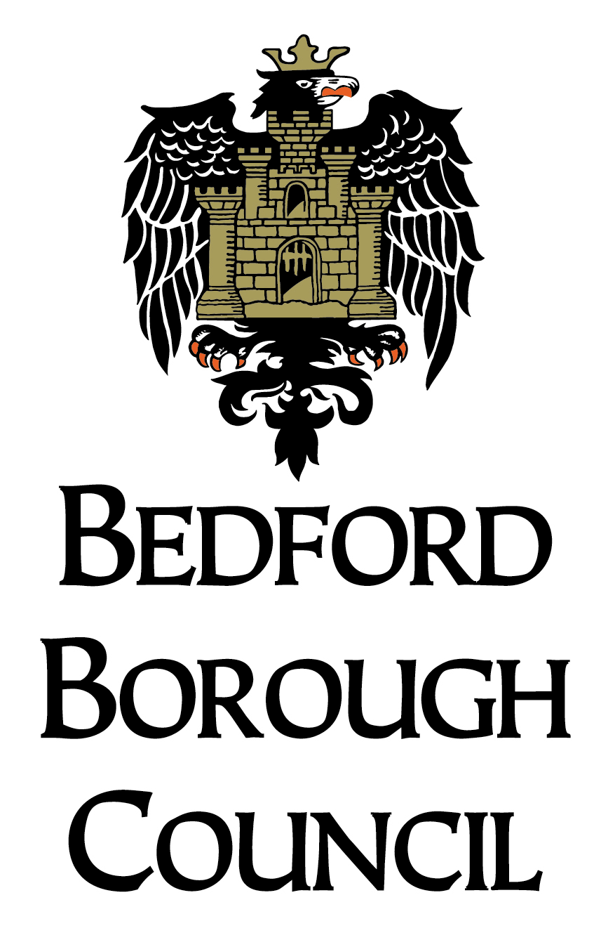April 2018
FREE SCHOOL MEAL APPLICATION
For pupils attending BEDFORD BOROUGH SCHOOLS ONLY

Use BLOCK CAPITALS and SIGN at the bottom of form

Title |  |  | Surname

Other Names
National Insurance No |  |  |  |  |  |  |  | OR NASS No

Email:
Contact Tel number: |  |  |  |  |  | Your date of birth
Your Address …….……………………………………………………………………………………………..
……………………………………………….........…POST CODE…………………………… Write below the details of each dependent child living with you and in full time attendance at a Bedford Borough school.
Surname | Other names | Date of birth | Name of school | Relationship to applicant
I am entitled to claim free school meals. (Tick the box to indicate which benefit you receive.)
- Income Support
- income-based Jobseeker’s Allowance
- income-related Employment and Support Allowance
- support under Part VI of the Immigration and Asylum Act 1999
- the guaranteed element of Pension Credit
- Child Tax Credit (provided you’re not also entitled to Working Tax Credit and have an annual gross income of no more than £16,190)
- Working Tax Credit run-on – paid for 4 weeks after you stop qualifying for Working Tax Credit
- Universal Credit – if you apply on or after 1 April 2018 your household income must be less than £7,400 a year (after tax and not including any benefits you get)
Children who get paid these benefits directly, instead of through a parent or guardian, can also get free school meals.
Declaration I have read the information overleaf and agree that you will use the information I have provided to process my claim for free school meals and will contact other sources as allowed by law to verify my initial and ongoing entitlement. I understand that if I give false information I may be prosecuted. I undertake to notify FSM administration IMMEDIATELY if:
- I change my address
Signed……………………………………………………….. | Date……………………..
(The person making the claim)
NOTE: Incomplete forms will result in unnecessary delays
Complete the form and return either to your child’s school to be forwarded to the address below or post direct to:
Return Address: Free School Meals Officer
Bedford Borough Council
Borough Hall
Cauldwell Street
Bedford
MK42 9AP

Contact numbers: Telephone: 01234 228948
Fax number: 01234 276014
Important: We cannot refund the cost of any school meals taken before you make this application.
Please continue to pay for school meals or provide a packed lunch until your entitlement has been confirmed.
We will contact your child’s school as soon as we have been able to confirm your entitlement. This may be on the same day as your application.
We will check that you meet the qualifying criteria. Data provided by the Department for Education and collected from the Department for Work and Pensions, the Home Office and HM Revenue and Customs will be accessed to do this.
Registering your child for FSM will also attract Pupil Premium funding for the school. Although it is recommended your child eat the meal, this is optional – you should register regardless of whether they want a meal.

Did you know … just registering your child for Free School
Meals means that the school will get extra money?

Register now to make sure they don’t miss out

The Government is giving money to schools to help children from lower income families do their very best. This funding is called ‘Pupil Premium’.

The authority is under a duty to protect the public funds it administers and to this end may use the information you have provided on this form within this authority for the prevention and detection of fraud. It may also share this information with other bodies administering public funds solely for these purposes.

Data Protection Act Personal information that you have provided will be used carefully and may be held on computer systems at the school and in the Children’s Services Department. These uses of personal information are covered by registration under data protection legislation. Under this legislation you have the right to obtain a copy of the information we hold about you.

