Reading
Enjoy reading and listening to stories, poems and non-fiction texts.

- Listen to, discuss and express views about a wide range of poetry, stories and non-fiction
- Retell story/ recount main themes & events.
- Comment on plot, setting & characters in familiar & unfamiliar stories.
- Predict what might happen next based on what has been read so far
- Read ahead to help with fluency & expression.
- Read aloud with expression & intonation, taking account of punctuation.
- Recognise:
  - speech marks
  - contractions
- Use contents and index pages to locate information.

Writing
Enjoy writing for a range of different purposes.

- Write different kinds of sentence: statement, question, exclamation, command.
- Use expanded noun phrases to add description & specification.
- Write using subordination (when, if, that, because).
- Correct & consistent use of present tense & past tense.
- Correct use of verb tenses.
- Correct & consistent use of capital letters, full stops, question marks or exclamation marks to punctuate sentences.
- Use commas in a list.
- Use apostrophe for omission e.g. don’t
- Introduction of speech marks.
- Write under headings.
- Begin to join letters with evidence of diagonal & horizontal strokes to join handwriting.





Mathematics
Number and place value
- Compare & order numbers up to 100.
- Read & write all numbers to 100 in digits & words.
- Say 10 more/less than any number to 100.
- Count in multiples of 2, 3 & 5 & 10 from any number up to 100.
- Recall & use multiplication & division facts for 2, 5 & 10 tables.
- Recall & use +/- facts to 20.
- Derive & use related facts to 100.
- Recognise place value of any 2-digit number.

Addition and subtraction
  - 2-digit numbers & ones
  - 2-digit numbers & tens
  - Two 2-digit numbers
  - Three 1-digit numbers
- Recognise & use inverse (+/-) e.g 23+34= 57 so 57-34=23

Multiplication and division
- Calculate & write multiplication & division calculations using multiplication tables.
- Recognise & use inverse (x/÷) e.g 5X2=10, so 10÷5=2
- Recognise, find, name & write 1/3; 1/4; 2/4; 3/4.
- Recognise equivalence of simple fractions e.g. 1/2= 2/4
Time
- Tell time to five minutes, including quarter past/to.


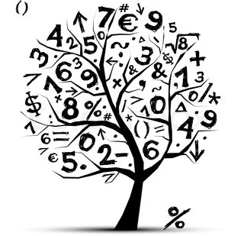

St Lawrence Church of England
Primary School



End of Year Expectations
Year 2

This booklet provides information for parents and carers on the National Curriculum Expectations for children at the end of Year 2

The objectives will be worked on throughout the year, with planning and differentiation of work to meet individual children’s needs.

