

Reading

Increase familiarity with and enjoyment of a wide range of books, including fairy stories, myths and legends and retelling some of these orally

- Give a personal point of view on a text.
- Can re-explain a text with confidence.
- Justify inferences with evidence, predicting what might happen from details stated or implied.
- Use appropriate voices for characters within a story.
- Identify how sentence type can be changed by altering word order, tenses, adding/deleting words or amending punctuation.
- Skim & scan to locate information and/or answer a question.

Writing

Enjoy writing for a range of different purposes and audiences

- Vary sentence structure, using different openers.
- Use adjectival phrases (e.g. biting cold wind).
- Appropriate choice of noun or pronoun.
- Apostrophe for singular & plural possession.
- Comma after fronted adverbial (e.g. Later that day, I heard bad news.).
- Use commas to mark clauses.
- Use connectives to link paragraphs.
- Legible, joined handwriting of consistent quality.

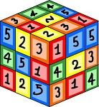
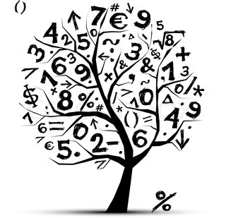
Mathematics

- Count backwards through zero to include negative numbers.
- Compare & order numbers beyond 1000.
- Compare & order numbers with 2 decimal places.
- Read Roman numerals to 100.
- Find 1000 more/less than a given number.
- Count in multiples of 6, 7, 9, 25 & 1000.
- Recall & use multiplication & division facts all tables to 12x12.
- Recognise place value of any 4-digit number.
- Round any number to the nearest 10, 100 or 1000.
- Round decimals with 1dp to nearest whole number.

Addition and subtraction
  - Numbers with up to 4-digits using efficient written method
  - Numbers with up to 1decimal place
Multiply
  - 2-digit by 1-digit number
  - 3-digit by 1-digit number
Divide:
  - 3-digit by 1-digit number
- Count up/down in hundredths.
- Write equivalent fractions
- Add and subtract fractions with same denominator.
Time
- Read, write & convert time between analogue & digital 12 & 24 hour clocks.

St Lawrence Church of England
Primary School



End of Year Expectations
Year 4

This booklet provides information for parents and carers on the National Curriculum Expectations for children at the end of Year 4
The objectives will be worked on throughout the year, with planning and differentiation of work to meet individual children’s needs.

