

Reading

- Summarise main points of an argument or discussion within their reading & makes up own mind about issue/s.
- Can compare between two texts.
- Appreciates that people use bias in persuasive writing.
- Appreciates how two people may have a different view on the same event.
- Draw inferences and justify with evidence from the text.
- Varies voice for direct or indirect speech.
- Recognise:
  - clauses within sentences
- Uses more than one source when carrying out research.
- Creates set of notes to summarise what has been read.

Writing

- Add phrases to make sentences more precise & detailed.
- Use range of sentence openers – judging the impact or effect needed.
- Begin to adapt sentence structure to text type.
- Use pronouns to avoid repetition.
- Use:
  - Brackets.
  - Dashes.
  - Commas.
- Use commas to clarify meaning or avoid ambiguity.
- Link clauses in sentences using a range of subordinating & coordinating conjunctions.
- Use verb phrases to create subtle differences (e.g. she began to run).
- Consistently organize into paragraphs.
- Link ideas across paragraphs using adverbials of time (e.g. later), place (e.g. nearby) and number (e.g. secondly).
- Legible and fluent handwriting style.

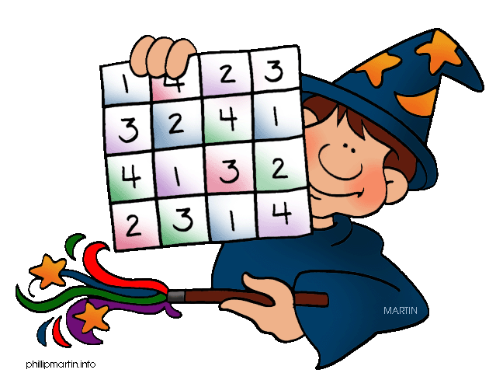
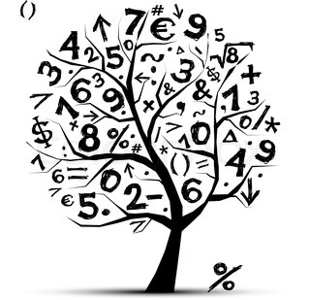
Mathematics
- Count forwards & backward with positive & negative numbers through zero.
- Count forwards/backwards in steps of powers of 10 for any given number up to 1000000.
- Compare & order numbers with 3 decimal places.
- Read Roman numerals to 1000.
- Identify all multiples & factors, including finding all factor pairs.
- Use known tables to derive other number facts.
- Recall prime numbers up to 19.
- Recognise place value of any number up to 1000000.
- Round any number up to 1000000 to the nearest 10, 100, 1000, 10000 or 100000.
- Round decimals with 2dp to nearest whole number & 1dp.
Addition & subtraction
  - Numbers with more than 4-digits using efficient written method (column).
Multiply
  - 4-digits by 1-digit/ 2-digit
Divide
  - 4-digits by 1-digit
Multiply & divide
  - Whole numbers & decimals by 10, 100 & 1000
Fractions
- Count up/down in thousandths.
- Recognise mixed numbers & fractions & convert from one to another.
- Multiply proper fractions by whole numbers.
- Solve time problems using timetables and converting between different units of time.

St Lawrence Church of England
Primary School



End of Year Expectations
Year 5

This booklet provides information for parents and carers on the National Curriculum Expectations for children at the end of Year 5

The objectives will be worked on throughout the year, with planning and differentiation of work to meet individual children’s needs.

